Abby Sedivy, Joe Duppstadt, Brice Baerga

**CREATING DATABASE:**

CREATE DATABASE finalProject;

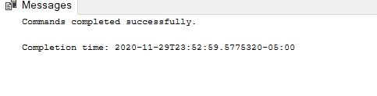

**Creating Types for the Database:**

CREATE TYPE DonorID FROM INT NOT NULL;

CREATE TYPE Name FROM VARCHAR(255) NOT NULL;

CREATE TYPE Address FROM VARCHAR(255) NOT NULL;

CREATE TYPE Phone FROM VARCHAR(255) NOT NULL;

CREATE TYPE Email FROM VARCHAR(255) NOT NULL;

CREATE TYPE Role FROM INT NOT NULL;

CREATE TYPE Category FROM VARCHAR(255) NOT NULL;

CREATE TYPE ParentOf FROM VARCHAR(255) NOT NULL;

CREATE TYPE Position FROM VARCHAR(255) NOT NULL;

CREATE TYPE GraduationYear FROM VARCHAR(255) NOT NULL;

CREATE TYPE CorpName FROM VARCHAR(255) NOT NULL;

CREATE TYPE Amount FROM INT NOT NULL;

CREATE TYPE Date FROM VARCHAR(255) NOT NULL;

CREATE TYPE planID FROM INT NOT NULL;

CREATE TYPE DonorTier FROM VARCHAR(255) NOT NULL;

CREATE TYPE PledgeID FROM INT NOT NULL;

CREATE TYPE fundraiserID FROM INT NOT NULL;

CREATE TYPE AmountLeft FROM INT;

CREATE TYPE nextPaymentDate FROM VARCHAR(255);

CREATE TYPE ClassRepID FROM INT NOT NULL;

CREATE TYPE YOG FROM INT NOT NULL;

CREATE TYPE ReunionDate FROM VARCHAR(255) NOT NULL;

CREATE TYPE nameOfFundraiser FROM VARCHAR(255) NOT NULL;

CREATE TYPE location FROM VARCHAR(255) NOT NULL;

CREATE TYPE season FROM VARCHAR(255) NOT NULL;

CREATE TYPE attendance FROM VARCHAR(255) NOT NULL;

CREATE TYPE volunteerID FROM INT NOT NULL;

CREATE TYPE Job FROM VARCHAR(255) NOT NULL;

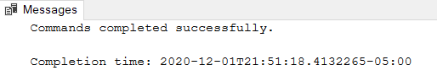

**Potential Donor**

CREATE TABLE PotentialDonor (

DonorID DonorID,

Name Name,

Address Address,

Phone Phone,

Email Email,

Role Role,

PRIMARY KEY (DonorID, Role)

);



**Sub Classes**

DROP TABLE GraduatingSenior

CREATE TABLE GraduatingSenior (

DonorID DonorID,

Role as 1 persisted, -- graduating senior

Category Category,

foreign key (DonorID, Role) references PotentialDonor(DonorID, Role)

)

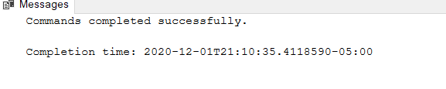

DROP TABLE Parent

CREATE TABLE Parent (

DonorID DonorID,

Role as 2 persisted, -- parent

ParentOf ParentOf,

foreign key (DonorID, Role) references PotentialDonor(DonorID, Role)

)



DROP TABLE Staff

CREATE TABLE Staff (

DonorID DonorID,

Role as 3 persisted, -- staff

Position Position,

foreign key (DonorID, Role) references PotentialDonor(DonorID, Role)

)



DROP TABLE Alumni

CREATE TABLE Alumni (

DonorID DonorID,

Role as 4 persisted, -- alumni

GraduationYear GraduationYear,

foreign key (DonorID, Role) references PotentialDonor(DonorID, Role)

)



DROP TABLE Corporation

CREATE TABLE Corporation (

DonorID DonorID,

Role as 5 persisted, -- corporation

CorpName CorpName,

foreign key (DonorID, Role) references PotentialDonor(DonorID, Role)

)



DROP TABLE Faculty

CREATE TABLE Faculty (

DonorID DonorID,

Role as 6 persisted, -- faculty

Position Position,

foreign key (DonorID, Role) references PotentialDonor(DonorID, Role)

)



INSERT INTO PotentialDonor(DonorID, Name, Address, Phone, Email, Role)

VALUES

(1, 'Gabriel Bloom', '51 E. Clay Street', '757-213-8167' ,'gbloom56@gmail.com','Senior'),

(2, 'Kara Bray' ,'7710 Summer Street', '757-215-3256' ,'karabray@outlook.com', 'Staff'),

(3, 'Francesco Searle' ,'3225 Wimbledon Way', '757-332-4533' ,'francescosearle@gmail.com' ,'Parent'),

(4, 'Bea Searle', '3225 Wimbledon Way', '757-443-4532' ,'beasearle@yahoo.com', 'Alumni'),

(5, 'Shauna Delgado', '1083 Holland Road', '814-306-7745' ,'shaunadelgado@gmail.com','Staff'),

(6, 'Rachel Bridges', '433 Lynnhaven Drive' ,'757-335-5633' ,'rachelbridges@outlook.com', 'Senior'),

(7, 'Sky Ingram', '753 Seatack Road', '757-307-4433' ,'skyingram@outlook.com' ,'Corporation'),

(8,'Krish Owen', '466 Lynnhaven Drive' ,'757-318-5543', 'krishowen@outlook.com', 'Faculty');

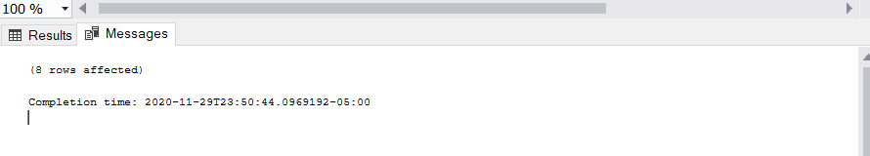

SELECT * FROM PotentialDonor

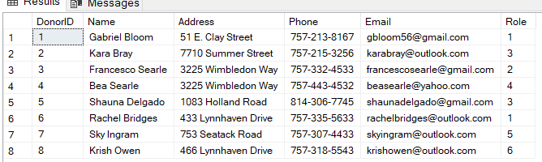

INSERT INTO GraduatingSenior(DonorID, Category) VALUES (1, 'Graduating Senior');

INSERT INTO Staff(DonorID, Position) VALUES (2, 'Staff - Janitor');

INSERT INTO Parent(DonorID, ParentOf) VALUES (3, 'Parent of Bea Searle');

INSERT INTO Alumni(DonorID, GraduationYear) VALUES (4, 'Graduated 2016');

INSERT INTO Staff (DonorID, Position) VALUES (5, 'Staff - Professor');

INSERT INTO GraduatingSenior(DonorID, Category) VALUES (6, 'Graduating Senior');

INSERT INTO Corporation(DonorID, CorpName) VALUES (7, 'Apple Inc.');

INSERT INTO Faculty(DonorID, Position) VALUES (8, 'Receptionist');



**Donations Table**

DROP TABLE Donation;

CREATE TABLE Donation (

DonorID DonorID,

Amount Amount,

Date Date,

planID planID,

PRIMARY KEY (DonorID, planID)

);

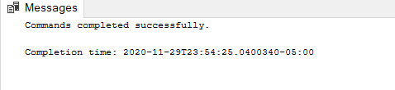

INSERT INTO Donation(DonorID, Amount, Date, PlanID) VALUES

(2,10000,'4/6/2020',1),

(5,100,'4/7/2020',2),

(4,15000,'4/7/2020',3),

(7,20000,'10/16/2020',4),

(8,100,'10/15/2020',5);

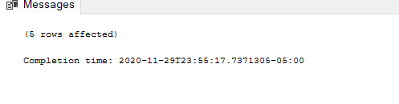

SELECT * FROM Donation

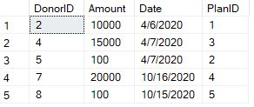

**DonationTier Table \*\*\*\*\*\*\*\*\*\*\*\*\*\*\*\*\*\***

DROP TABLE DonationTier;

CREATE TABLE DonationTier (

DonorID DonorID,

Amount Amount,

DonorTier DonorTier,

PRIMARY KEY (DonorID, Amount)

);

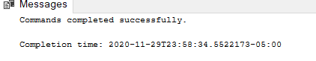

INSERT INTO DonationTier(DonorID, Amount, DonorTier) VALUES

(2, 10000, 'Silver'),

(5, 100, 'Regular'),

(4, 11000, 'Silver'),

(7, 20000, 'Gold'),

(8, 100, 'Regular');

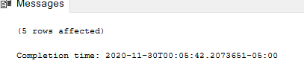

SELECT * FROM DonationTier

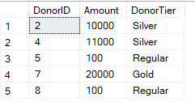

**Pledge**

DROP TABLE Pledge;

CREATE TABLE Pledge (

DonorID DonorID,

PledgeID PledgeID,

Date Date,

Amount Amount,

fundraiserID fundraiserID,

PRIMARY KEY (PledgeID)

);

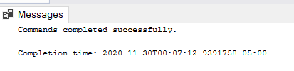

INSERT INTO Pledge (DonorID, PledgeID, Date, Amount, FundraiserID) VALUES

(1,1,'4/6/2020',500,1),

(3,2,'4/6/2020',10000,1),

(6,3,'4/7/2020',50,2),

(4,4,'4/7/2020',15000,2),

(5,5,'10/15/2020',100,3);

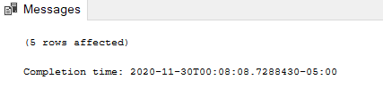

SELECT * FROM Pledge

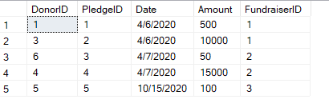

**Payment Plan**

DROP TABLE PaymentPlan

CREATE TABLE PaymentPlan (

AmountLeft AmountLeft,

nextPaymentDate nextPaymentDate),

planID planID,

PRIMARY KEY (planID)

);

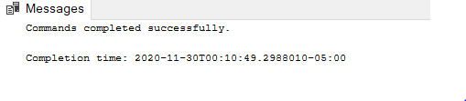

INSERT INTO PaymentPlan(AmountLeft, nextPaymentDate, planID) VALUES

(NULL, NULL, 1),

(NULL, NULL, 2),

(4000, '4/22/2020', 3),

(NULL, NULL, 4),

(NULL, NULL, 5);

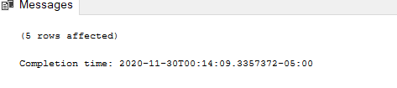

SELECT * FROM PaymentPlan

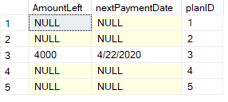

**ClassRep**

DROP TABLE ClassRep;

CREATE TABLE ClassRep (

ClassRepID ClassRepID,

Name Name,

YOG YOG,

Role Role,

Phone Phone,

ReunionDate ReunionDate,

fundraiserID fundraiserID,

PRIMARY KEY (ClassRepID)

);

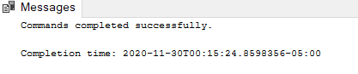

INSERT INTO ClassRep (ClassRepID, Name, YOG, Role, Phone, ReunionDate, FundraiserID) VALUES

(1, 'Bea Shearle',2020, 'Graduated', '757-443-4532', '4/25/2025', 1),

(2, 'Benjamin Rosas',2015, 'Graduated', '757-223-3223', '9/5/2020', 2),

(3, 'Archie Rogers',2010, 'Graduated', '757-322-2353', '9/18/2020', 3),

(4, 'Mylo Hibbert', 2022, 'Current', '757-844-2023', '4/25/2027', 4),

(5, 'Betty Healy', 2021, 'Current', '814-345-4334', '10/15/2026', 5);

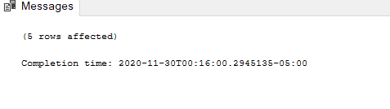

SELECT * FROM ClassRep

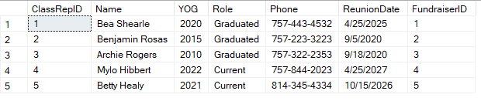

**Fundraising Events**

DROP TABLE FundraisingEvents;

CREATE TABLE FundraisingEvents (

fundraiserID fundraiserID,

nameOfFundraiser nameOfFundraiser,

location location,

season season,

attendance attendance,

Date Date

ClassRepID ClassRepID,

PRIMARY KEY (FundraiserID)

);

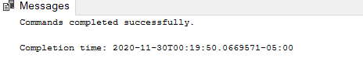

INSERT INTO FundraisingEvents(FundraiserID, nameOfFundraiser, location, season, attendance, Date, volunteerID, classRepID) VALUES

(1, 'Spring Golf Outing', 'Red Wing Lake Golf Course', 'Spring', 42, '4/6/2020', 3, 1),

(2, 'Spring Golf Outing', 'Stumpy Lake Golf Course', 'Spring', 45, '4/7/2020', 2, 2),

(3, 'Summer Pool Party', 'Hilton Ocean Front', 'Summer', 58, '7/25/2020', 5, 3),

(4, 'Fall Homecoming', 'ODU', 'Fall', 92, '10/15/2020', 1, 4),

(5, 'Fall Homecoming', 'ODU', 'Fall', 102, '10/16/2020', 4, 5);

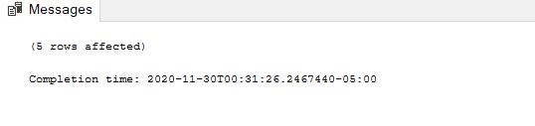

SELECT * FROM FundraisingEvents

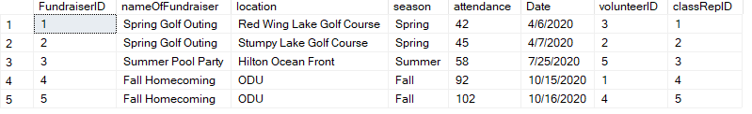

**Volunteer**

CREATE TABLE Volunteer (

volunteerID volunteerID,

Email Email,

Name Name,

Address Address,

Phone Phone,

Job Job,

fundraiserID fundraiserID,

PRIMARY KEY(volunteerID)

);

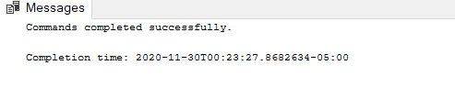

INSERT INTO Volunteer (volunteerID, Email, Name, Address, Phone, Job, fundraiserID) VALUES

(1, 'maizieD43@gmail.com', 'Maizie Davies', '3733 Oliverio Drive', '757-233-2521', 'Concession Stand', 4),

(2, 'elizarhodes98@outlook.com', 'Eliza Rhodes', '2372 Heavner Avenue', '757-211-2332', 'Admissions', 2),

(3, 'sofiadunbar@outlook.com', 'Sofia Dunbar', '2821 Augusta Cir', '757-655-4343', 'Clean Up', 1),

(4, 'nikolashayden87@yahoo.com', 'Nikolas Hayden', '3960 Rica Drive', '757-319-3442', 'Admissions', 5),

(5, 'dominickodonnell@gmail.com', 'Dominick Odonnell', '1232 Green Cedar Ln', '757-239-0021', 'Concession Stand', 3);

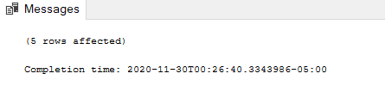

SELECT * FROM Volunteer

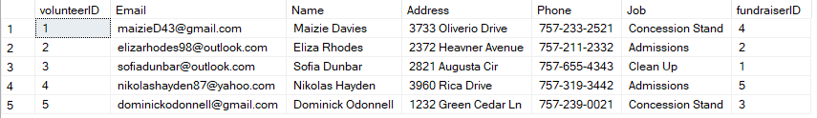

**Foreign Keys**

ALTER TABLE Donation

ADD CONSTRAINT fkPlanID FOREIGN KEY(planID) REFERENCES PaymentPlan(planID)

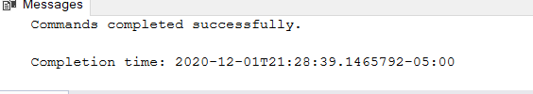

ALTER TABLE Pledge

ADD CONSTRAINT fkPledgeFID FOREIGN KEY(fundraiserID) REFERENCES FundraisingEvents(fundraiserID)



ALTER TABLE ClassRep

ADD CONSTRAINT fkClassFID FOREIGN KEY(fundraiserID) REFERENCES FundraisingEvents(fundraiserID)



ALTER TABLE FundraisingEvents

ADD CONSTRAINT fkClassRep FOREIGN KEY(ClassRepID) REFERENCES ClassRep(ClassRepID)



ALTER TABLE FundraisingEvents

ADD CONSTRAINT fkVolunteer FOREIGN KEY(volunteerID) REFERENCES Volunteer(volunteerID)



ALTER TABLE Volunteer

ADD CONSTRAINT fkVolFID FOREIGN KEY(fundraiserID) REFERENCES FundraisingEvents(fundraiserID)



**Views**

CREATE VIEW DonorsWithAmount AS

SELECT p.donorID, p.name, p.role, d.amount

FROM Donation d JOIN potentialDonor p ON d.donorID = p.donorID

WHERE amount > 0

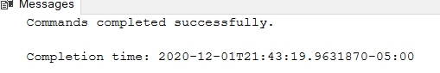

SELECT * FROM DonorsWithAmount

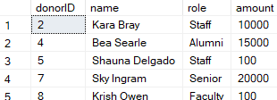

CREATE VIEW DonationAmountLeft AS

SELECT d.DonorID, d.Amount, p.planID,p.amountLeft, p.nextPaymentDate

FROM Donation d JOIN PaymentPlan p ON d.planID = p.planID

WHERE amountLeft > 0



SELECT * FROM DonationAmountLeft



CREATE VIEW PledgesThatBecameDonations AS

SELECT d.DonorID, p.pledgeID, p.amount, p.dayOfDonation

FROM Donation d JOIN Pledge p ON d.DonorID = p.DonorID

WHERE p.amount > 0



SELECT * FROM PledgesThatBecameDonations

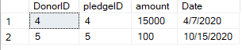

CREATE VIEW GraduatingSeniors AS

SELECT p.DonorID, p.Name, p.Role, g.Category

FROM PotentialDonor p JOIN GraduatingSenior g ON p.DonorID = g.DonorID

WHERE p.Role = 1



SELECT * FROM GraduatingSeniors

CREATE VIEW WhoVolunteeredAt AS

SELECT v.volunteerID, v.name, f.fundraiserID, f.nameOfFundraiser, f.location

FROM Volunteer v JOIN FundraisingEvents f ON v.volunteerID = f.volunteerID

WHERE nameOfFundraiser = 'Spring Golf Outing'



SELECT * FROM WhoVolunteeredAt

